**CMSC 203**

**Fernando Gonzales-Vigil Richter**

**Assignment 2**

**Pseudocode**

DISPLAY "Ticket Manager"

WHILE continue is true

DISPLAY "Enter the name of the violator: "

READ name

DO

DISPLAY "Enter the speed of the violator (>0): “

READ speed

WHILE speed is minus than 0

DO

DISPLAY “Enter the speed limit (>0,<=80> : “

READ speedlimit

WHILE speedlimit is minus than 0 or greater than 80

DO

DISPLAY “Was this in a school zone (Y/N) : ”

READ school

IF school is Y or y THEN schoolzone is true

ELSE IF school is N or n THEN schoolzone is false

ELSE repeat is true

WHILE repeat is true

DO

DISPLAY “Was this in a work zone (Y/N): ”

READ work

IF work is Y or y THEN schoolzone is true

ELSE IF work is N or n THEN schoolzone is false

ELSE repeat is true

WHILE repeat is true

IF (speed-speedLimit) greater than 30 THEN

IF workzone is true then fine is 360

ELSE IF schoolzone is true then fine is 310

IF speed-speedLimit greater than 40 then fine is fine + 675

ELSE fine is fine + 450

ELSE IF speed-speedLimit > 10

IF workzone is true then fine is 360

ELSE IF schoolzoneis true then fine is 310

ELSE fine is 195

IF speed-speedLimit is greater than 20 then fine is fine + 300

ELSE IF speed-speedLimit is greater than 0

IF workzone is true then fine is 250

ELSE IF schoolzone is true then fine is 200

ELSE fine is 140

COMPUTE fine as double, day at court, ticket number and driving zone

DISPLAY “Department of Motor Vehicles

Automated Traffic Enforcement

Dear **name**,

Please pay the following speeding fine of $**fine** to the DMV within 10 days of receiving this notice to avoid a driver's license suspension. You are being fined for going **speed** MPH in a **speed limit** MPH **driving zone.**

Ticket Type: **ticket** **type**

You must appear at the County Court House on October **day at court**, 2018.

Ticket Number: **ticket number**

Returned checks are subject to a returned check fee of $35.00

Sincerely

Fernando Gonzales-Vigil

Do you want to enter another ticket? (Y/N):”

READ userchoice

IF userchoice is equal to N THEN continue is false

DISPLAY “Exiting the Ticket Manager “

DISPLAY "Programmer: Fernando Gonzales-Vigil"

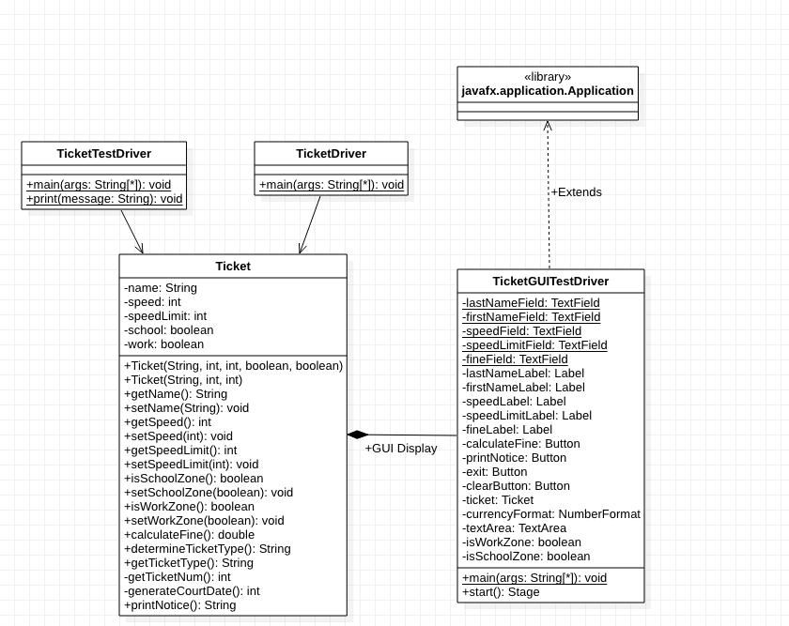

Test Cases

|  |  |  |  |  |  |  |
| --- | --- | --- | --- | --- | --- | --- |
| No. | Name | Speed | Speed Limit | School Zone | Work Zone | Fine |
| 1 | Albert Einstein | 45 | 40 | true | false | 200.00 |
| 2 | Isaac Newton | 45 | 30 | true | false | 310.00 |
| 3 | John Doe | 50 | 25 | false | false | 300.00 |
| 4 | Lewis Hamilton | 55 | 20 | false | true | 810.00 |
| 5 | Freddy Mercury | 5000 | 80 | false | true | 1035.00 |
| 6 | Willy E. Coyote | -20/20 | 90/-20/20 | false | false | 0.00 |

**Lessons Learned**

Some of the material required in this assignment like validation was also included in the previous course CMSC 140, however the nested if-else was more difficult. There were chances of errors because the complexity of the requirement was high, with many options. Without the Driver Test provided, testing could have failed because the expected output was not clear. The main lesson to learn is to have the expected output very clear, especially if you create your own tests. Solving the nested if-else was more difficult without clear expectations made it more difficult.

Some additional new things were using DecimalFormatter as a better option to printf and other good leson is the practice to create the JavaDoc, and how to add description to classes, methods, and parameters.